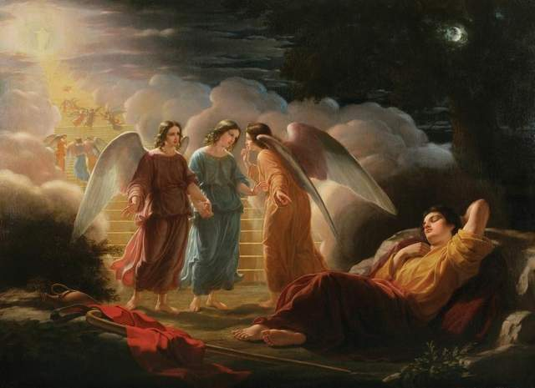

**Prayer: “Bring More of What I Dream”**

*O God, who out of nothing brought everything that is,  
out of what I am, bring more of what I dream but haven’t dared;  
direct my power and passion to creating life where there is death,  
to putting flesh of action on bare-boned intentions,  
to lighting fires against the midnight of indifference,  
to throwing bridges of care across canyons of loneliness;  
so I can look on creation, together with you,  
and, behold, call it very good;  
through Jesus Christ my Lord.*

By Ted Loder, *Guerrillas of Grace: Prayers for the Battle,* p. 115

**What We Know About Dreams in the Bible:**

~There are 21 dreams recorded. 11 are in the book of Genesis.  
~ 2 dreamers were named Joseph. Only 1 woman!  
Go to [www.overviewbible.com/?s=dreams](http://www.overviewbible.com/?s=dreams) for a fun overview of each dream

**Carl Jung’s definition of DREAMS:**

Specific **expressions of the unconscious** which have a definite, purposeful structure indicating an underlying idea or intention. The general function of dreams is to restore one's total psychic equilibrium. Psyche is made up of:  
~Ego- conscious part of our personality  
~Subconscious- below, inferior to consciousness.   
~Unconscious- parts of our personality we do not know.

*That is to says dreams are ALWAYS about restoring us to health and wholeness.  
Dreams are suggesting what we fail to acknowledge in daily life (but may already know)*

**Types of Dreams**:

Top of Form

***Daydreams***

You spend an average of 70-120 minutes a day, daydreaming or fantasizing from a perspective that transcends normal perception

***Lucid Dreams***

Lucid dreams occur when you ‘wake up’ while dreaming. Many people wake themselves up within the dream to remain in this lucid state to explore how they can influence dreams.

***Nightmares***

This is a dream that reflects actual trauma or an unresolved crisis or fear. It is always a WAKE-UP CALL to learn to let go. Dreaming is a ‘safe place’ that allows these difficult ideas to be explored.

***Recurring Dreams***

Whatever you are avoiding or not facing will continue to be the subject matter of your dream, until it is resolved.

***Dreams About Healing***

Most therapists recognize repression at the root of illnessness, aches and pains. Since dreams portray what you are repressing, they are a profound tool in achieving wellness and balance. You may recognize symbolism for certain parts of your body.

***Prophetic Dreams***

These dreams contain some sort of “foresight” probably based upon things your subconscious is storing but you have yet to recognize fully conscious.

***Life Changing (Epic) Dreams***

These dreams typically occur during periods when you are actively undergoing transformation. They are vivid and typically stay with you for a lifetime. They may even be so potent that you make a “life change” because of them.

Spend a few moments reflecting about these types of dreams. Which ones do you most frequently have? Is there anything you would like to note about them?

________________________________________________________________________________

________________________________________________________________________________

________________________________________________________________________________

________________________________________________________________________________

**Working with Dreams:** *Always center in prayer first, recall it in memory, sit with it in silence until they are ready.*

1. Story-ing the Dream: Title the dream (essence of the dream), theme (an expansion of the title), describe emotional responses to each part of dream, question the dream.
2. Conversing with the Dream: What wants to be noticed? (images, characters, objects, emotions) Initiate a conversation with whatever presents itself. You may tell it what you want it to do, what you need.
3. Drawing the Dream: Use pencil to change if necessary. Draw shapes, use colors, arrows to indicate order or movement. While you are drawing, notice thoughts and feeling that emerge, jot them down on art page. It’s the process, not the outcome that matters!
4. Poet-ing the Dream: What predominates the dream? (event, action, image or emotional mood?) This becomes the subject of the poem.

*Finally, thank the dream (image, character, object, emotion, etc)   
and the dream giver for whatever purpose it has served!

Preparation Before Sleep: Place journal and pen by bed!

Prayer:

*Give me a candle of the Spirit, O God  
as I go down into the deep of my  
own being.*

*Show me the hidden things. Take me  
down to the spring of my life, and  
tell me my nature and my name.*

*Give me freedom to grow so that I  
may become my true self – the  
fulfillment of the seed which you  
planted in me at my making. Amen*.